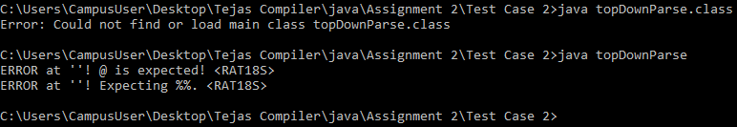

C:\Users\CampusUser\Desktop\Tejas Compiler\java\Assignment 2\Test Case 2>java topDownParse ERROR at ''! @ is expected! <RAT18S> ERROR at ''! Expecting %%. <RAT18S>